**DAILY ONLINE ACTIVITIES SUMMARY**

|  |  |  |  |  |  |  |  |  |
| --- | --- | --- | --- | --- | --- | --- | --- | --- |
| **Date:** | 10-06-2020 | | | | | **Name:** | Anvitha H M | |
| **Sem & Sec** | 4th ‘A’ | | | | | **USN:** | 4AL18CS010 | |
| **Online Test Summary** | | | | | | | | |
| **Subject** | | Object oriented concepts | | | | | | |
| **Max. Marks** | | 30 | | **Score** | | | 4 | |
| **Certification Course Summary** | | | | | | | | |
| **Course** | Front end development - CSS. | | | | | | | |
| **Certificate Provider** | | | Great learning academy | | **Duration** | | | 8 hours |
| **Coding Challenges** | | | | | | | | |
| **Problem Statement:** 1. Program in C to print the sum of boundary elements of a matrix.  2.. Java program to find the longest repeating sequence in a string.  3. Java program to count all the triplet such that sum of 2 elements equals the third elements. | | | | | | | | |
| **Status:** Executed | | | | | | | | |
| **Uploaded the report in Github** | | | | | YES | | | |
| **If yes Repository name** | | | | | <https://github.com/alvas-education-foundation/Anvitha-H-M> | | | |
| **Uploaded the report in slack** | | | | | Yes | | | |

**Online test:**

The online test was from modules 3 and 4, all the questions were objective type questions. All questions were optimal and were easy. The score that I got was 4/30.

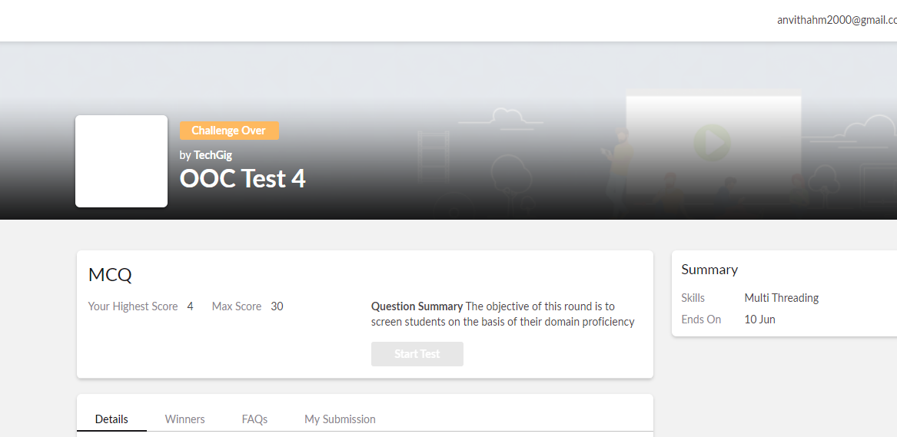

**Certification course:**

Front end development - CSS

The course includes introduction to CSS, inline styling, external styling, type, ID and selector with exercising assignment and quiz.

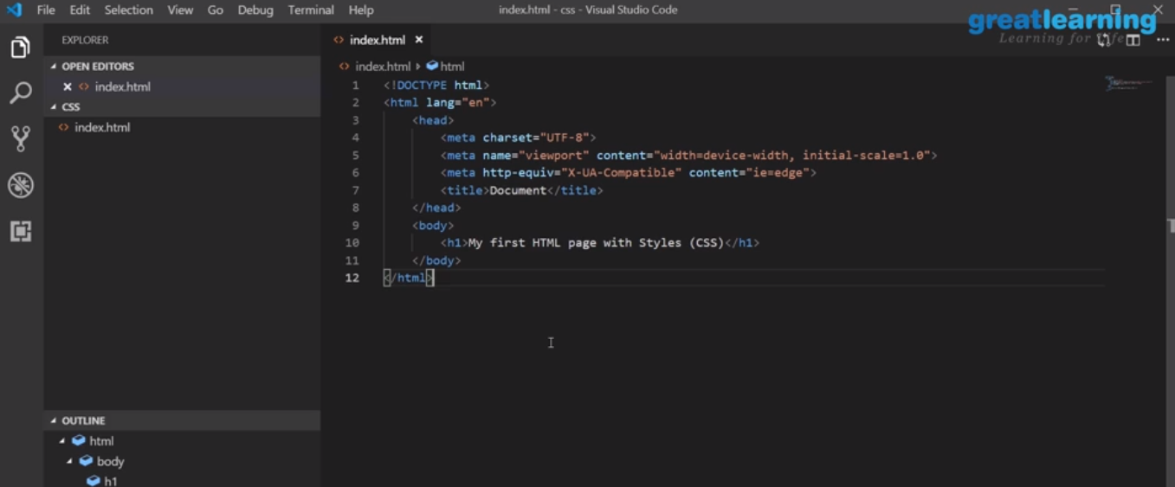

Online coding challenge

The programing statements of the day are

1. Program in C to print the sum of boundary elements of a matrix.

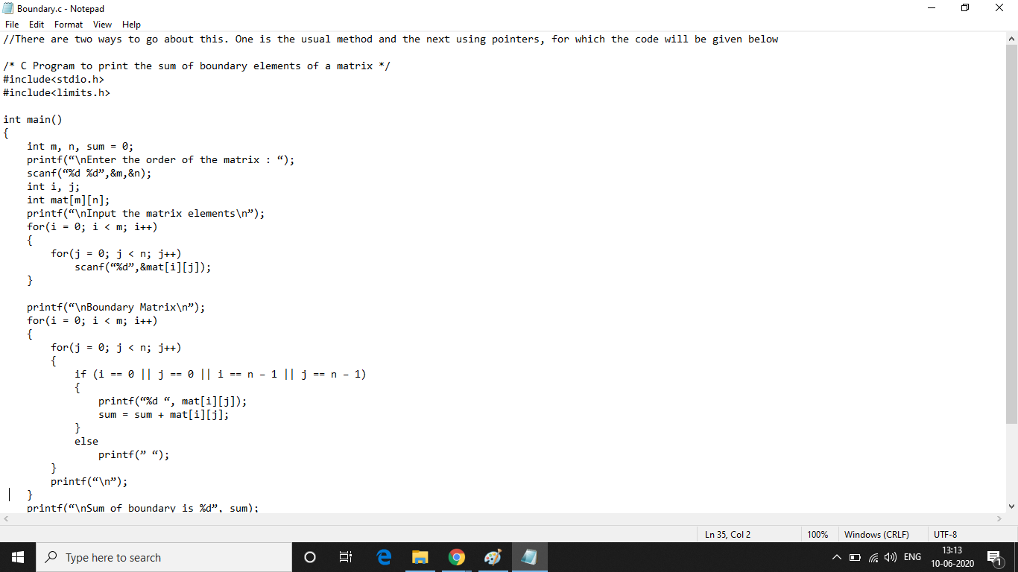

2.. Java program to find the longest repeating sequence in a string.

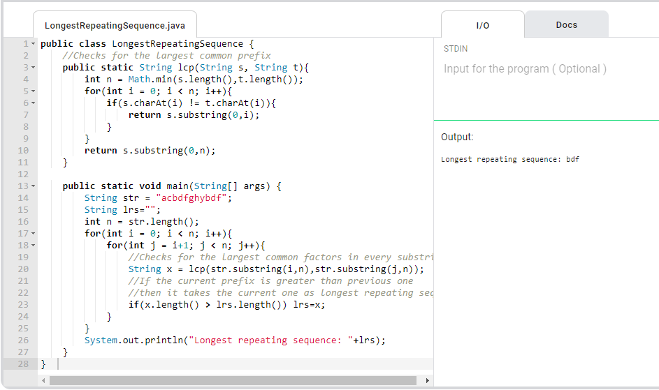

3. Java program to count all the triplet such that sum of 2 elements equals the third elements.

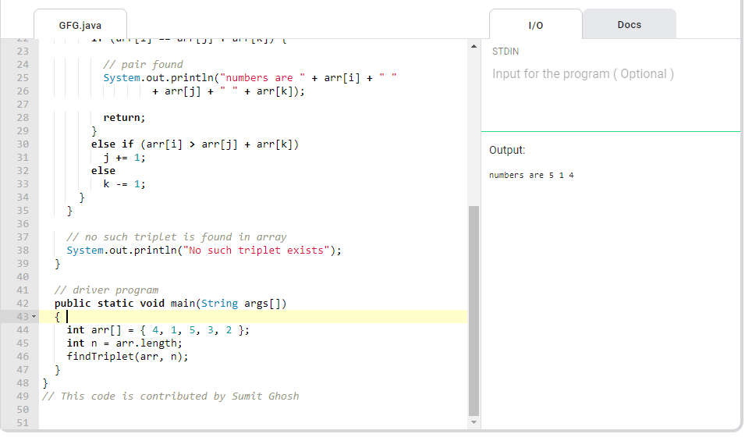

Solution: Executed and uploaded in Github repository.

Link: <https://github.com/alvas-education-foundation/Anvitha-H-M>